Marco – Pit Bull, Trail Dog, Inspiration
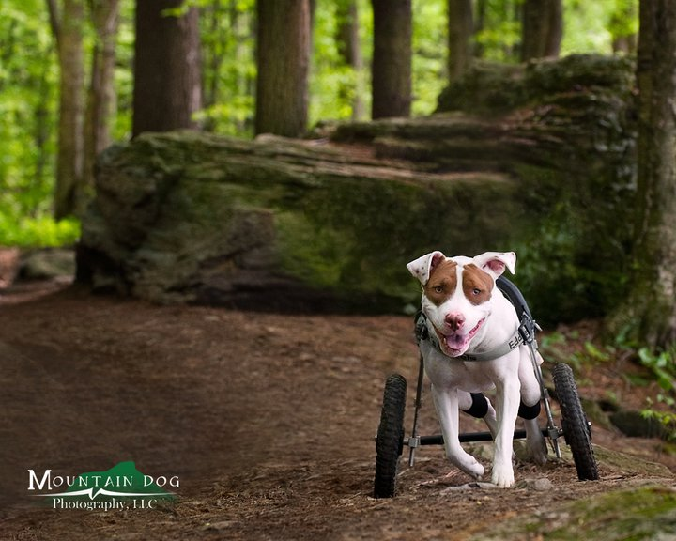

THE REWARDS OF ADOPTING SPECIAL NEEDS PETS

You will often hear the saying, “rescued pets make the best pets,” but until you have adopted a dog or cat, and witnessed the change that happens when they finally trust that they are in a forever home, you can not understand what it truly means.

If you are brave enough to walk into a shelter, the first thing you notice is the blank, desperate, and fearful look in the eyes of those waiting to learn their fate. They wag their tails, or shmooze at the cage door, hoping to get your attention, but at the same time, fearful of how you may react. They desperately want to trust that you are going to save them, but they are hesitant. Maybe you will just abandon them again. Maybe you will be worse than the homes they had before. Maybe they will end up on the street again. They are so eager to please, but experience has taught them to be wary.

For those animals with a medical condition, the situation is even worse. Most times, their condition can not be treated while they are in the shelter. Many have chronic infections or illnesses that may have been part of the reason why they were turned into the shelter. Their conditions may cause them pain or discomfort, or make them feel sick, which makes them all the more likely to be passed over by potential families. Dogs rely on human contact and interaction to lead normal lives. Generations of breeding have programmed them to please people...it is part of their purpose in life. Without that bond, they are isolated and broken. If they spend too long in the shelter, their spirit breaks, and that can make their illness worse. They can spiral downward until it becomes more humane to euthanize them than to make them wait for a home that will likely never come.

What people don't understand, is how rewarding it is to adopt a special needs pet. An animal without hope gradually begins to trust that you are their new family and a loyal bond develops. They are forever grateful and eager to please, and comfort. They are happy just to see you come home, just to be pet or cuddled, just to go for a walk or play ball. There is a brightness in their eyes, and a swagger that comes as they gradually feel better and are made comfortable. Before you know it, you begin to brighten when you see how much happier they are and how they seem to smile in their eyes when you call their name. As they slowly worm their way into your heart, you begin to feel like they are rescuing you as much as you have rescued them. For each of you have given the other a sense of purpose and belonging. You have saved a life and it is amazing what a balm to the soul that feeling can be.

I write this newsletter in honor of a family that adopted a dog that most people would have walked past. Marco's first strike is that he is a Pit Bull. Most people know this breed and think “vicious dog.” Those that truly know this breed, know them as the ultimate survivors, and the most forgiving friends. Many shelters won't even take in a Pittie, because they know many families won't consider adopting them just because of their false reputation. But Marco had a second strike against him. He had escaped a local puppy mill but had the misfortune of running in front of a car. His back was broken, with no chance that he would ever walk again. 99% of the rescues or veterinary clinics would have recommended euthanasia. It is hard enough to find a home for a Pittie, let alone one that needs a cart to get around and assistance to urinate and defecate. One technician at the veterinary clinic in Vermont that saved his life, saw something in his eyes and couldn't just give up on him. They understood that sometimes, you just have to give them a fighting chance, and in doing so, brought an entire town together to help his cause. This dog took that chance, and flourished.

The family that adopted Marco has made a career out of rescuing greyhounds. When they read Marco's story, they knew that they had to look past his breed and his disability, and meet him. Once they met him, they knew they had to adopt him. I have only had the pleasure of meeting him a few times, but watching him chase a ball, take over the clinic couch, and wag and wiggle for everyone he meets in the waiting room, makes me literally laugh out loud. I can't imagine the work involved in his care, but I know how I feel when I help make someone's pet feel better. I imagine if you asked that technician in Vermont whether or not it was worth everything she did to save Marco, or if you asked Mark and Kerri if all the day to day care for Marco is worth it, neither would hesitate. They would each tell you watching him be a happy dog, is good for the soul, and the heart. They would each tell you, that saving his life, has greatly enriched theirs. I think they would tell you, that every time he chases a ball or plays with the greyhounds, their world gets a little brighter.

So the next time you are thinking that your family needs a furry companion, please remember, adopting a pet is saving a life. And we could all use a little good Karma on our side.

The Compassionate Care Veterinary Clinic offers a 20% discount on services for dogs and cats that are adopted from shelters or rescue organizations, for 6 months after adoption. For more information on how and where to adopt, please visit our adoption page.



